Silent Echo - balance of wellbeing and high-end
The highest standards of material, form and function: Under the LAUFEN umbrella, Alape will be presenting innovations at the ISH from 17 to 21 March 2025 that take bathroom design to a new level of aesthetics and precision. The company, which has been part of the Roca Group since 2023, will be presenting ground-breaking innovations and further developments to its product portfolio in Frankfurt. Alape presents its latest design highlight with new PVD-coated 3mm basins and also showcases an absolute world first: the brand demonstrates its expertise in the coating process for 3D-printed basins as part of an impressive production.

Versatility in perfection: Alape's surface innovation
With RIVO, Alape is expanding its portfolio with a metal washbasin series. The PVD-coated 3 mm basins open up creative freedom and a new dimension in material aesthetics. RIVO is available in brass, copper and brushed titanium finishes and is a perfect match for the PVD-coated LAUFEN Kartell taps.
The intensive exploration of surfaces characterises the Alape presentation at ISH 2025 and can be felt across every collection. This is particularly true of the Tricolor series, launched in 2024, Tricolor is available in three variants, that combine three harmoniously coordinated colours in a unique design, making an expressive statement in the bathroom.

Coating expertise for 3D-printed basins
Innovation is deeply embedded in the company’s manufacturing DNA. As a highlight of the trade fair, Alape is presenting a world premiere: its expertise in glazing processes combined with 3D-printed basins. Visitors can experience these remarkable innovations in the ‘Hidden Garden’ - a secluded garden area within the exhibition stand. Under the theme ‘Silent Echo’, the premium manufacturer invites guests to enter into a dialogue between water, material and space in this hidden oasis, offering a serene escape from the bustling trade fair environment. . Here, 3D-printed pool exhibits are elegantly showcased with high-quality glazing. The expertise in glazing 3D-manufactured washbasins using Alape's signature process unlocks entirely new possibilities for bespoke basin designs in the high-end project sector.

Aesthetic lightness meets masterful craftsmanship
It is not only washbasins such as Folio and Arkta—the latter having recently been honoured with the GDA 2025 award for its minimalist Nordic bathroom furniture elements—that await visitors at the trade fair. For the first time at ISH, LAUFEN will also present an exclusive furniture piece featuring a washbasin from Alape.
With Arun | Tendo, the premium manufacturer introduces its exquisitely designed bowl basin, launched last year, which appears to float effortlessly atop the washbasin surface. This refined piece is elegantly complemented by the Arun furniture from the LAUFEN portfolio, creating a sophisticated interplay of form and function.
Beyond demonstrating the seamless compatibility of LAUFEN taps with Alape basins, this presentation underscores how both manufacturers combine precision, masterful craftsmanship, and state-of-the-art technology with timeless elegance in a perfectly balanced symbiosis.

Alape Bespoke: perfect customisation for sophisticated bathroom design
Another distinguished highlight of the presentation is the range of Bespoke solutions, which masterfully combine exclusive materials such as natural stone, glazed steel, and wood. Among these, In & Out captivates with its sophisticated showcase design, as the basin is neither fully recessed into the natural stone countertop nor positioned on top of it. Instead, it appears to emerge seamlessly from the console, creating an organic and fluid integration of materials. This innovative design achieves a perfect equilibrium between the basin and its supporting structure, resulting in an elegant and refined aesthetic.
For discerning interiors, Alape offers the option of customising In & Out to accommodate individual design requirements. The second Bespoke solution is distinguished by its precise craftsmanship and features a matching furniture base, ensuring a flawless fit for tailored niche installations. The elegantly shimmering RIVO basin is exquisitely showcased on the natural stone countertop, complemented by the harmoniously coordinated LAUFEN-Kartell mixer tap—an eye-catching ensemble that enhances the bathroom’s sophisticated design language.

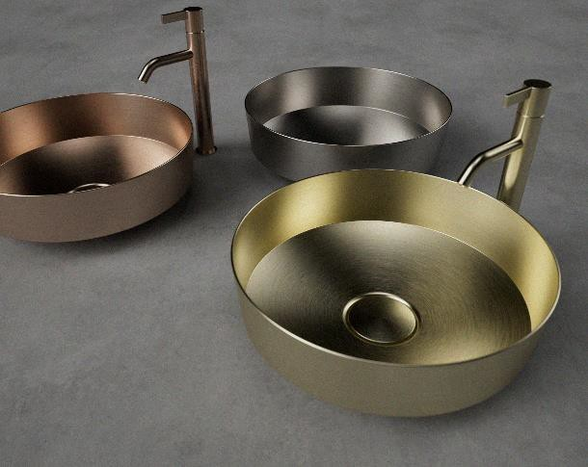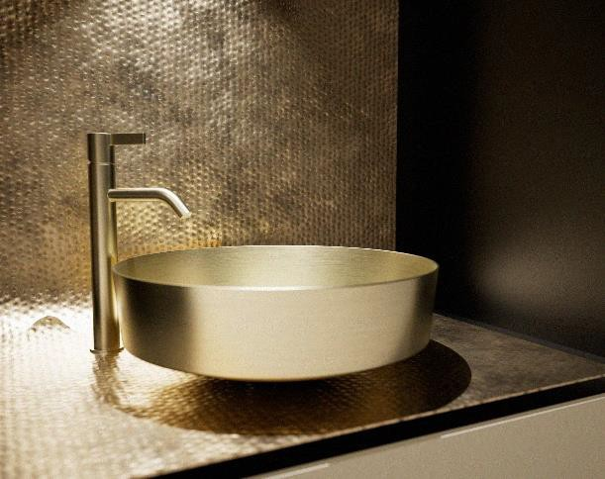
Elegant surfaces, unusual materials: the new RIVO washbasin series sets stylish accents in the bathroom with PVD-coated versions in brushed brass, copper and titanium.
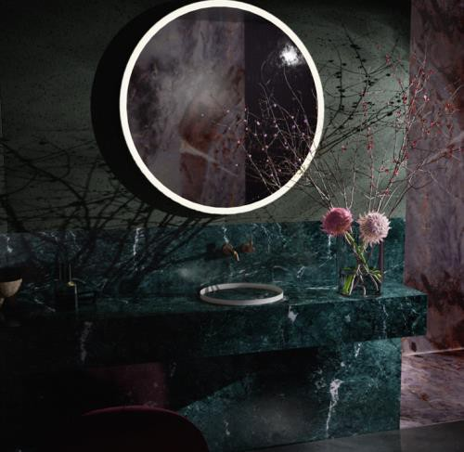
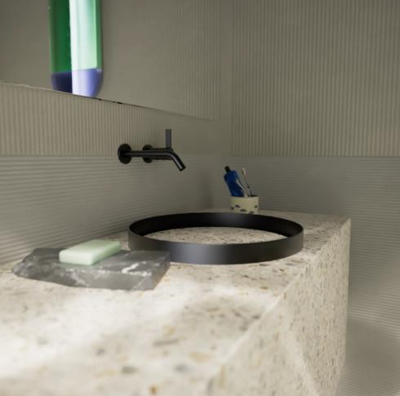
In&Out redefines the washbasin and ensures a balance between architectural clarity and seamless sophistication.
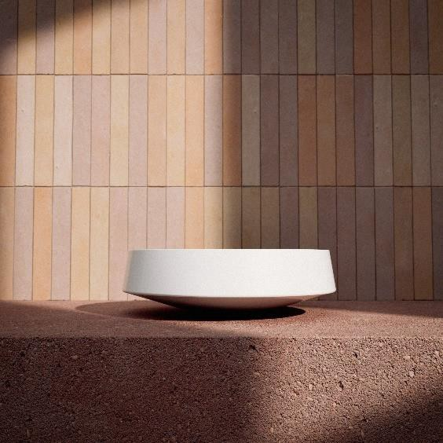
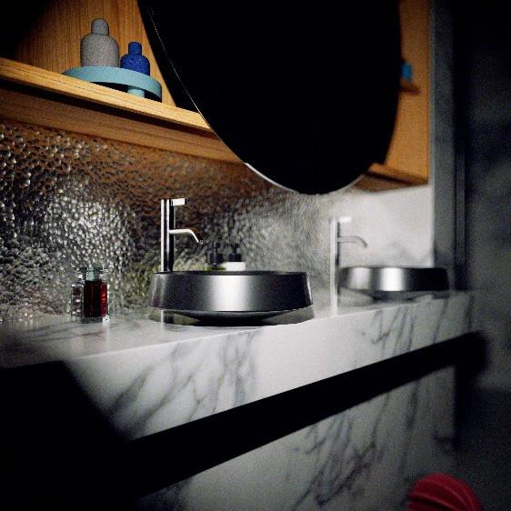
Nib as an eye-catcher in any bathroom: the tapered underside creates an impressive floating effect.

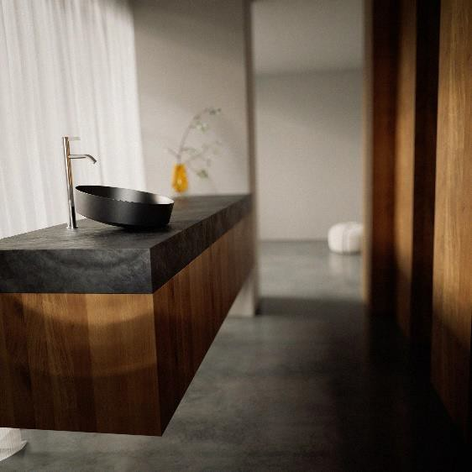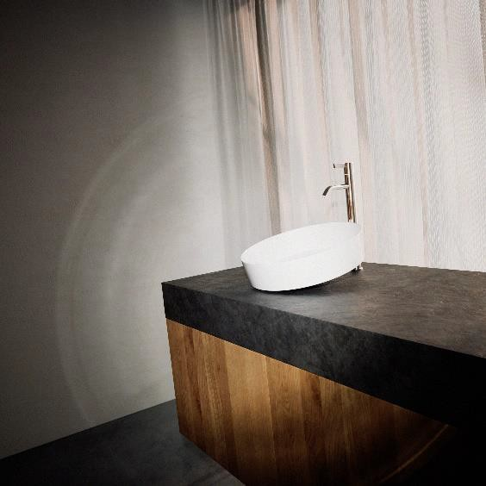
The Tendo basin from Alape adds a playful and sensual touch to the bathroom with its innovative, angled design.
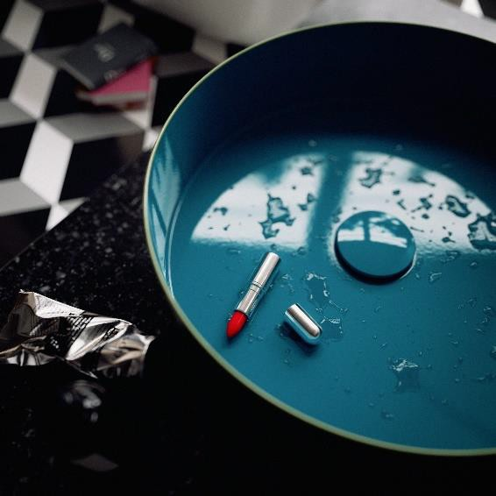
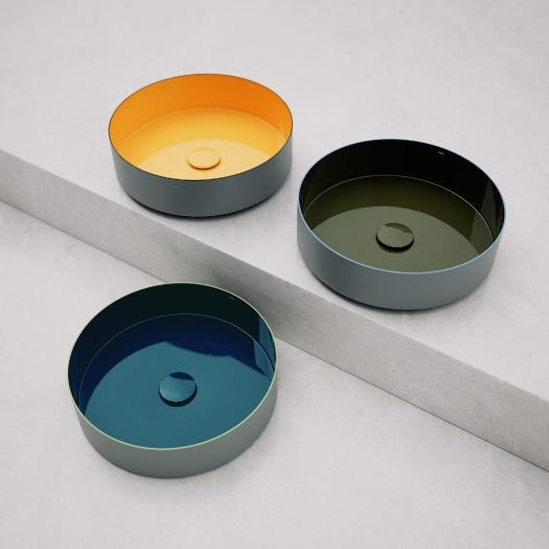
Tricolor from Alape opens up new, creative freedom in the bathroom with its combination of three different colour surfaces.

About Alape
Alape was founded in 1896 by Adolf Lamprecht in Penig as a company for enamel products. Today, the enterprise creates aesthetic washplace solutions with around 100 employees at two production sites in Goslar. As a manufacturer, Alape stands for technical and functional quality standards and inspiring design. By combining glazed steel with other high-quality materials, Alape produces distinctive designs tailored for elegant interior spaces.
alape.com

Press contact:

GeSK
Gabriele von Molitor
alape@gesk.berlin
Tel: +49 30 217 50 460

Alape
Marketing
marketing@alape.com
Tel. +49 5321 558-139
alape.com

