Life in vibrant hues: Tricolor from Alape

Alape’s Bicolor washbasins thrive on an interplay of contrasts, as black meets white and matte surfaces meet glossy finishes. Now the new Tricolor version is taking this to another dimension: surprising combinations of three different colours create an elegant and versatile look – offering the ultimate scope for adding a personal touch to your bathroom.

Good things come in threes, and that applies to Tricolor too, with a different colour on the inside, the outside and along the narrow edge of the round, wafer-thin washbasin. This unique concept captures the imagination and provides the creative freedom to make your interior design wishes come true, whether you prefer a classic or more unconventional style. You might want a dynamic look that blends several brightly coloured elements to generate impact, or a calmer atmosphere with splashes of colour creating subtle accents – either way, the three-coloured basin allows you to tailor your bathroom to your own tastes.

In addition to the play of colours, varied textures are another hallmark feature of the Tricolor design, with smooth enamel set against rough glazed steel. The contrast between matte and glossy surfaces is appealing both to the eye and to the touch, taking your washplace to a whole new sensory level. Tricolor is available in three different colour combinations: Tuscany, Petrol and Olive.

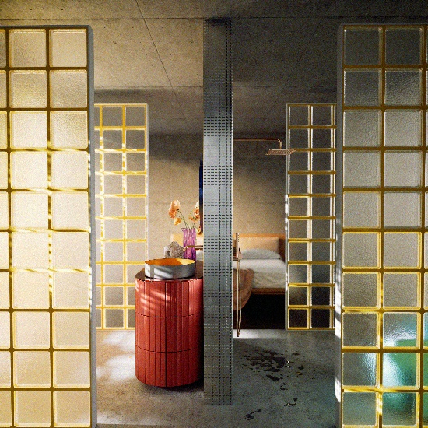 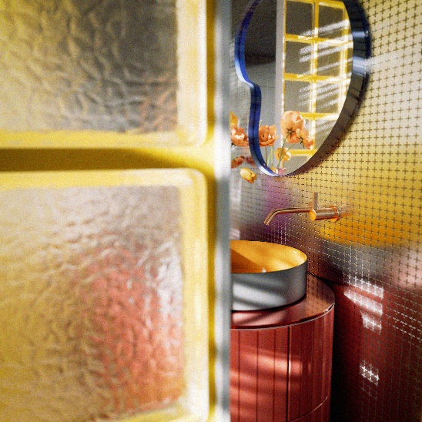
Colour contrasts to capture the imagination: by combining three different-coloured surfaces, Alape’s Tricolor offers fresh creative scope for bathroom design. Here, the matte grey finish on the outside of the basin forms an elegant counterpoint to the inside in Tuscany and the edge in Olive.

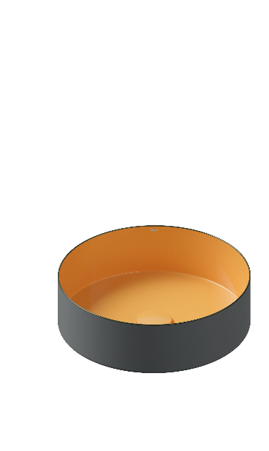 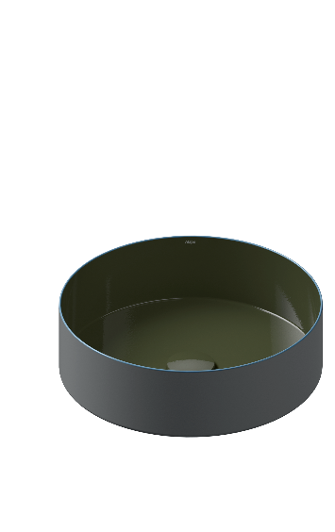 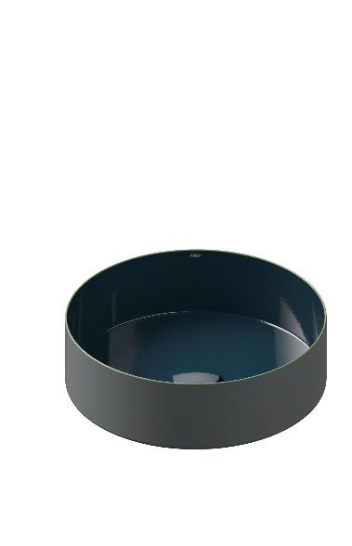
Simple, elegant and unconventional: Tricolor in the variants Tuscany, Olive and Petrol.

About Alape
Alape was founded in 1896 by Adolf Lamprecht in Penig as a company for enamel products. Today, the company employs around 100 people at two production sites in Goslar and produces aesthetic washplace solutions. As a manufacturer, Alape stands for technical and functional quality standards and inspiring design. Glazed steel in combination with other high-quality materials enables Alape's individual design for an interior-influenced environment. Alape has been part of the Spanish Roca Group since October 2023.
alape.com

Press contact:

GeSK
Gabriele von Molitor
alape@gesk.berlin
Tel: +49 30 217 50 460

Alape
Marketing
marketing@alape.com
Tel. +49 5321 558-139

