Poetry in motion: Tendo from Alape

Effortlessly elegant, remarkably functional: Tendo from Alape offers an innovative, unprecedented design approach. With its unique angled shape, Tendo seems to dance on the washstand, adding a touch of playfulness and sensual charm to any bathroom.

An unexpected sight at a surprising angle: Tendo shifts our perception and changes our expectations of how objects should be arranged in space. The new bowl basin from Alape greets users at a tilt, welcoming them with an inviting gesture. It is no coincidence that it is reminiscent of the bowl we form with our hands to scoop up and hold water. The innovative tilted shape not only impresses with its self-confidence and sense of style, but also offers a completely different way to present the water: it flows down the tilted surface like a waterfall, guaranteeing an unprecedented, unique washing experience.

The unusual design approach combines a poetically playful aesthetic with ergonomic sophistication and technical know-how. The fact that Tendo can approach us so openly is also thanks to his material: Once again, the glazed steel ensures that the delicate geometry of the basin and its tilted angle are reliably held in shape. Tendo is available in white, matt black and dark iron.

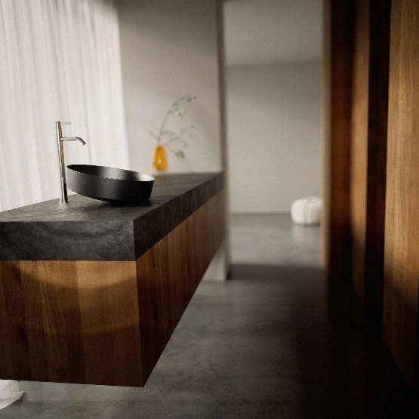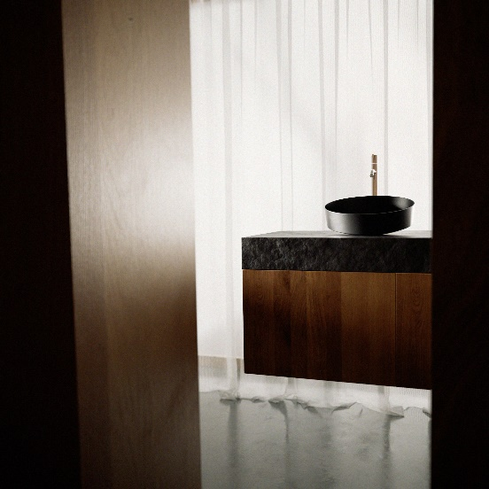
Elegance meets function: The Tendo basin from Alape in matt black gives the bathroom a playful and sensual touch with its innovative, angled design.

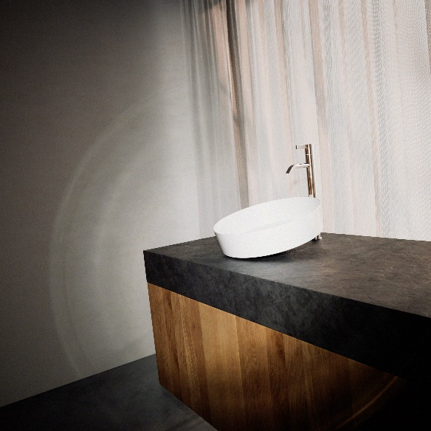
Modern and inviting: The Tendo bowl basin from Alape in brilliant white impresses with its unique tilted shape and incomparable washing experience.

About Alape
Alape was founded in 1896 by Adolf Lamprecht in Penig as a company for enamel products. Today, the company employs around 100 people at two production sites in Goslar and produces aesthetic washplace solutions. As a manufacturer, Alape stands for technical and functional quality standards and inspiring design. Glazed steel in combination with other high-quality materials enables Alape's individual design for an interior-influenced environment. Alape has been part of the Spanish Roca Group since October 2023.
alape.com
Press contact:

GeSK
Gabriele von Molitor
alape@gesk.berlin
Tel: +49 30 217 50 460

Alape
Marketing
marketing@alape.com
Tel. +49 5321 558-139

