


PRESS RELEASE

Goslar, 24.04.2024

Rethinking Routines.
Alape at the Salone del Mobile 2024

Questioning routines, rethinking habits: for Alape, this year's Salone del Mobile was all about change and transformation. The company from Goslar used the industry event in Milan to provide insights into its new aesthetic direction under the motto ‘Convert | ations’. The guiding principle of transformation was reflected in an abstract form: as an inspiring overall experience that incidentally refers to the bathroom trends of the future.
With its presence at the Salone del Mobile, Alape made its biggest international appearance to date since the brand became part of the Roca family of companies in October last year. ‘Our concept was aimed at asking questions and stimulating dialogue,’ says Andrea Jürgens, Head of Marketing and Design at Alape. ‘What conventions and codes are commonly associated with our idea of bathroom design? How do our expectations and needs evolve over time? And what if we were to playfully change our perspective on this again and again?’ She was very pleased with the large number of visitors: ‘We were in constant, stimulating dialogue with our partners and the numerous interested parties on site and received a lot of positive feedback, especially with regard to our new design approaches and concepts,’ says Jürgens happily.
Unusual angles and shapes
One highlight of the Alape trade fair stand: the new washstand innovations, which featured unusual, unprecedented design approaches. The new sloping bowl basin, for example, shifted the usual perception and greeted users with a sublime, inviting gesture. The water flowed naturally down the inclined surface like a waterfall, offering a completely new form of presentation. The tilting shape not only impressed with its self-confidence and style, it also guarantees a unique washing experience in ergonomic terms. Another new basin design virtually floated above the washstand, creating a light, weightless atmosphere with its sophisticated geometry.
Perfectly balanced connections
The idea of transformation was also particularly evident in the many unusual material combinations: steel, stone and wood embraced and channelled the water, creating perfectly balanced product ensembles. A steel basin looked as if it had sunk into the wooden surface of the washstand, while others were encased in an elegant, sculptural frame made of stone or wood. New colours and surface textures, including turquoise, gold and bronze, proved to be just as impressive. The highlight: an iridescent finish that changes from every angle. In contrast, the UNISONO Tricolor models set strong colour accents, combining deep blue, shiny enamel with a green rim and rough, dark grey steel, among others.

Tailor-made individualisations
Last but not least, Alape emphasised its commitment to transforming high-quality bathroom interiors into customised solutions for the home. The modular Arkta furniture series and the customisation programme demonstrated how greater personalisation can also be achieved for demanding architectural situations - including numerous colour variants and unique basin and material combinations. ‘Our aim was not only to present our new design approach, which combines clarity with emotionality and poetry, but also to clearly emphasise our expertise in customised solutions,’ explains Andrea Jürgens. ‘Judging by the great feedback, we succeeded in doing this.’

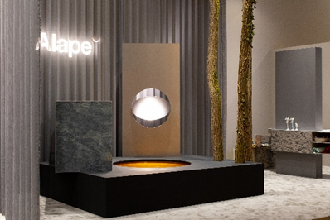 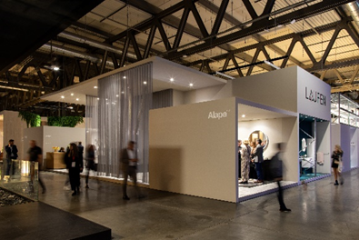
Source: Sofia Zambon, IPPO Production
Picture on left: Alape presents the main theme ‘Convert | ations’ as a highlight of the trade fair stand by combining high-quality materials such as glazed steel, stone and wood.
Picture on right: Together with investor ROCA and sister company LAUFEN, Alape presented the latest designer washplace solutions.
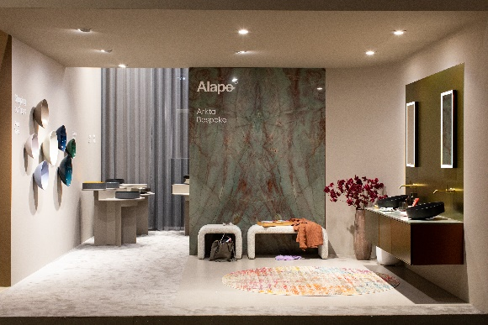 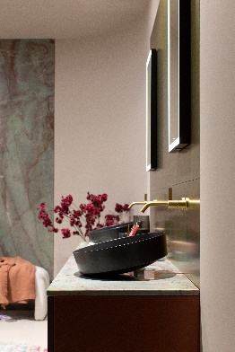
Source: Sofia Zambon, IPPO Production
In addition to tried-and-tested product series such as Aqua and Terra, Alape also exclusively presented its latest innovations. These included the ‘sloping’ basins in the Arkta range and two other new basins: the three-colour UNISONO Tricolor and the ‘floating’ basin.
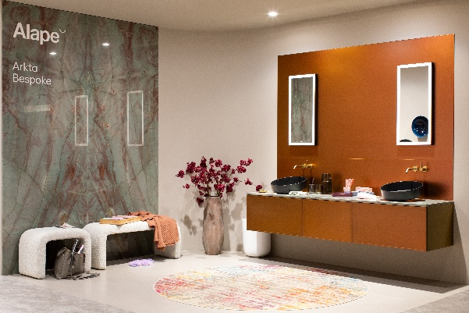 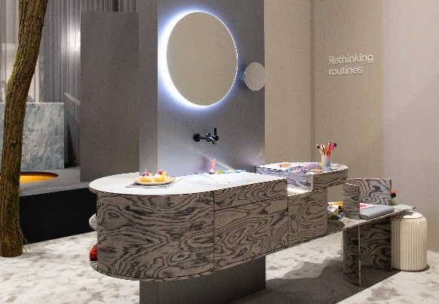
Source: Sofia Zambon, IPPO Production
Picture on left: With Arkta, Alape demonstrated its comprehensive expertise in customised design in the upmarket project segment. In addition to the natural stone slab from Neolith, an iridescent lacquer for the front, which changes colour depending on the incidence of light, and the latest ‘sloping’ washbasins ensured an impressive result. This special Arkta installation was customised exclusively for the trade fair.

Picture on right: The Alape show car was organised under the motto ‘Rethinking Routines’, which illustrated how the bathroom of the future can be designed: a harmonious combination of comfort, functionality and appealing design. This washplace solution is also unique and was specially manufactured for the trade fair.

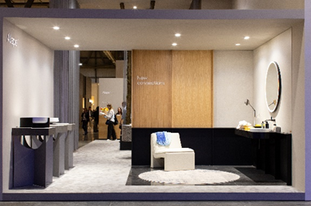 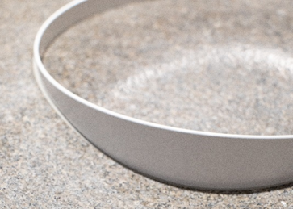
Source: Sofia Zambon, IPPO Production
Picture on left and right: Alape presented innovative ways of combining glazed steel, stone and wood under the theme of ‘Connections’.

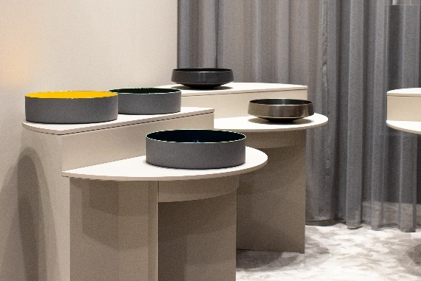 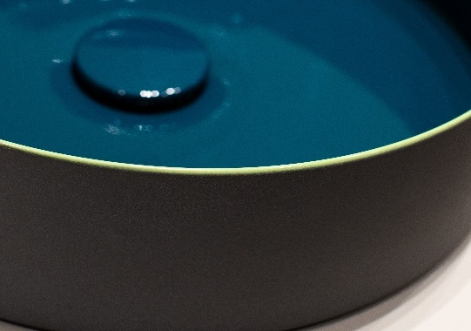
Source: Sofia Zambon, IPPO Production

Picture on left: Alape presented its latest innovations, including the UNISONO Tricolor, the ‘floating’ and the ‘sloping’ washbasin, each in different colour finishes.

Picture on right: The UNISONO Tricolor basin showcases Alape's precise craftsmanship with glazed steel, including a stunning colour scheme that creates a completely new basin.

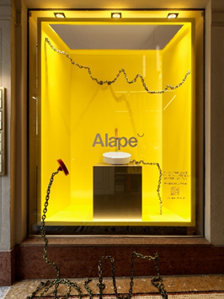 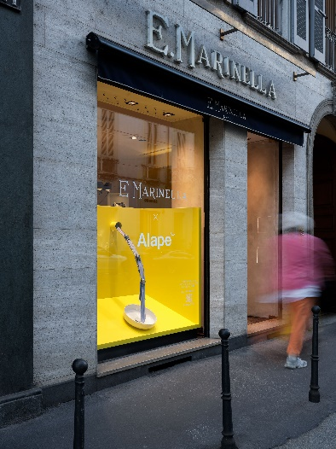 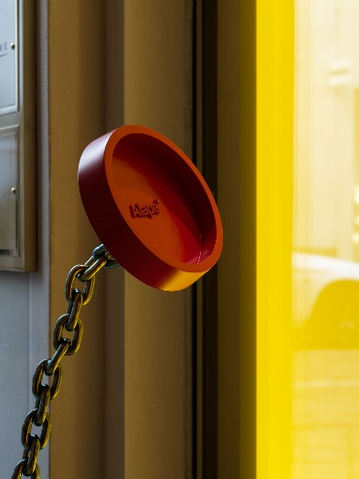
Source: Pierre Kellenberger
Pictures: At the Fuorisalone, Alape presented the ‘Connections’ theme in the E. Marinella store (tie shop) with a playful installation. In one shop window, a chain with a stopper was used, which appeared to protrude from the window. In another shop window, the ties of the E. Marinella store were staged as jets of water in an Alape washbasin.

About Alape
Alape was founded in 1896 by Adolf Lamprecht in Penig as a company for enamel products. Today, the company employs around 100 people at two production sites in Goslar and produces aesthetic washplace solutions. As a manufacturer, Alape stands for technical and functional quality standards and inspiring design. Glazed steel in combination with other high-quality materials enables Alape's individual design for an interior-influenced environment. Alape has been part of the Spanish Roca Group since October 2023.
alape.com

Press contact:

GeSK
Gabriele von Molitor
alape@gesk.berlin
Tel: +49 30 217 50 460

Alape
Marketing
marketing@alape.com
Tel. +49 5321 558-139

