KLAFS launches globally unique wellness concept: two new products for the optimised interaction of heat and cold
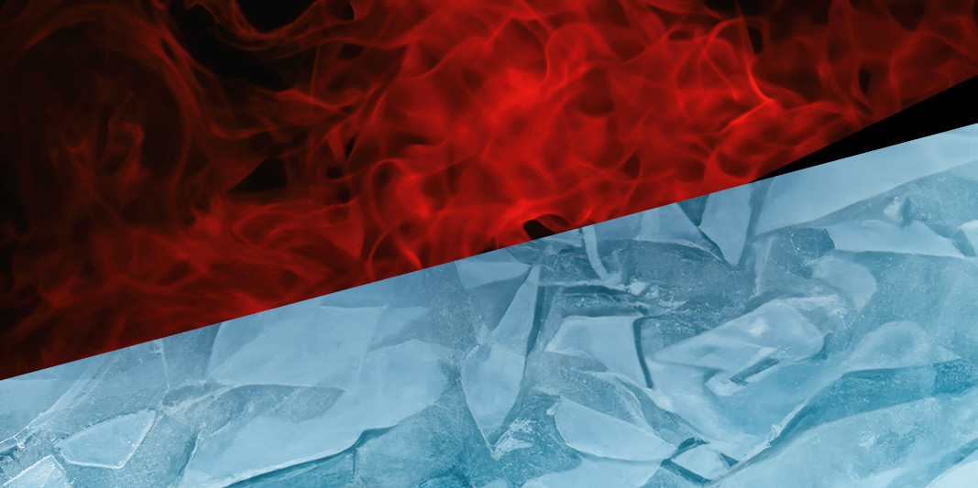
Only the perfect combination of heat and cold makes a holistic sauna experience possible. KLAFS - world market leader for sauna, wellness and spa - is now presenting two groundbreaking innovations that offer sauna operators in hotels, fitness studios, SPAs and other wellness facilities a unique concept and maximise the health benefits of saunas: the VITALITY BOOST, an automatic infusion system with targeted heat treatment, and the FRIMAS ice steam roomfor gentle, humid cooling. These innovations take the sauna experience to a new level and at the same time offer optimum relaxation for the body, customised to individual needs. KLAFS is once again setting new standards in the wellness sector.
For a holistic sauna experience: the interaction of heat and cold
Taking a sauna is far more than just a way to relax - it is a comprehensive ritual that revitalises body and mind and boosts our health. Stimulating impulses encourage our body to self-regulate and mobilise our defence mechanisms against external influences. The real secret of a holistic sauna experience therefore lies not only in the soothing warmth - its counterpart, the cold, is just as important a part of a sauna session. Both phases have their own benefits and contribute to the overall health effect: The heat in the sauna relaxes the muscles, promotes blood circulation, cleanses the body or reduces stress hormones. The subsequent cooling down in turn stimulates the immune system, improves the elasticity of the blood vessels and helps to relieve the body and stabilise the circulation. However, it is the combination of both stimuli that maximises the health and relaxing effects. It strengthens the cardiovascular system, blood circulation, immune defence and resilience. At the same time, the interplay ensures that the body quickly regains its inner balance. As a result, our body recovers more quickly and our general well-being is enhanced.
KLAFS has therefore developed two ground-breaking new products with which the sauna manufacturer offers its customers a complete wellness programme. It complements the applications for the optimised interaction of heat and cold with an intensive heat training, the VITALITY BOOST, and a gentle cooling, the FRIMAS ice steam room. With these two innovations, KLAFS now has a complete wellness programme: from gentle to intensive heat training or from moderate to powerful cooling - guests at the wellness facilities have the choice and can put together and enjoy their time-out according to their personal needs.
Intensive heat training with the VITALITY BOOST
The VITALITY BOOST - an automatic infusion with targeted air circulation - has been developed by KLAFS together with experts and infusion masters and forms the centrepiece of the innovative KLAFS concept on the heat side. The multifunctional system enables an increased sensation of warmth and therefore more intensive training of the heart, blood circulation and immune system. The automatic infusion system and the ceiling-mounted air jets ensure that the heat and humidity generated by the infusion are distributed quickly and evenly throughout the cabin. Guests at hotels, leisure pools, fitness centres and other commercial spa facilities can enjoy a perfect infusion experience at any time with the VITALITY BOOST, which is comparable to the ceremonies performed by master infusion therapists and is the perfect addition to public wellness areas.
The VITALITY BOOST complements the popular infusion events organised by infusion masters at specific times. This allows commercial spa centres to offer additional infusions at any time of day. And even in commercial spas that do not have their own staff for infusion events, guests can now enjoy an infusion ceremony with waving with the new VITALITY BOOST.
Year-round wellness cooling thanks to the FRIMAS ice steam room
After turbo training with the VITALITY BOOST, the body deserves to relax. To complement the intensive heat phase, KLAFS has therefore developed a new type of wellness cooling: the FRIMAS ice steam room, which offers year-round refreshment in the wellness area. This unique concept enables a moist, cold, gentle cool-down that perfectly rounds off the sauna bath and gently rebalances the body: At cabin temperatures of around 5°C, a fine mist is created in the room, which provides an increased sensation of cold - without directly exposing the body to too powerful a cold stimulus and overtaxing it. By avoiding an abrupt change from hot to cold and thanks to the moderate coldness of the ice mist bath, the body can regulate itself in a balanced way and gently adapt to the refreshing environment within 5-10 minutes. The sensation of cold has a balancing effect, relaxes the muscles, normalises the body temperature and brings the body into an optimal, pleasant state of relaxation after the sauna. This creates a hermetic, positive stress in which the body develops defence mechanisms and strengthens its resistance. The psychological stress that some bathers can experience due to a massive, direct cold stimulus is eliminated and cooling off becomes a true wellness experience.
The FRIMAS ice steam room impresses with its blue backlit acrylic blocks and can be customised in terms of size and applications: Snow, ice fog and authentic-looking ice surfaces offer a diverse range of cooling experiences and enhance the cold effect. New options such as the GLACIER ice wall with ice fog or the HOLLI ice steam shower can be combined with other spectacular elements such as the STALAGMIT and POLARIS ice fountains and the ATMOSPHERE, a screen with impressive images of nature. These components create cool accents that guests will remember for a long time. An unforgettable experience for all the senses.
Whether intensive training or moderate training: KLAFS offers a comprehensive product programme
As we all know, needs and preferences may vary. This also applies to the wellness sector. Those who prefer a gentler method of heating the body instead of intensive infusions with the VITALITY BOOST are best served by the SANARIUM®, which KLAFS was the first provider to introduce a few years ago. It enables a wide variety of bathing forms with milder temperatures and higher humidity.
KLAFS also offers a contrasting programme on the cold side. As an alternative to the FRIMAS ice steam room, KLAFS has a range of waterfall and bucket showers or cold water immersion pools for a powerful, intensive cold stimulus. They enhance the training effect by exposing the body to "supercompensation".
With the additional offer of the VITALITY BOOST and the FRIMAS ice steam room, KLAFS enables all conceivable variations of wellness treatments in the field of tension between heat and cold. Whether intensive or gentle - KLAFS now enables professional wellness providers to offer their guests an individually tailored programme and thus the optimum solution for their physical and mental well-being.

About KLAFS:
KLAFS has been creating places of relaxation for body and soul since 1928. Time and again, the company manages to surprise with groundbreaking innovations – such as the space-saving sauna KLAFS S1, which transforms from the size of a wall cabinet to a fully functional sauna within 20 seconds at the push of a button. Thanks to this innovative strength, KLAFS advanced from what was once a small family business to a global industry leader. Today, more than 800 employees work to meet - and exceed - the ever-increasing demands of customers. From small private sauna rooms to luxurious hotel spas. And they do this all over the world, with expert advice from carefully trained technical consultants and on-site service from experienced teams. As a trendsetter in the sauna, pool and spa industry, KLAFS continuously invests in research and development, for example to further increase the energy efficiency of its products.

