New floor-standing washstands by Alape:
minimalist and lightweight

For decades, Alape's glazed steel washstands and washbasins have been synonymous with stylistic versatility and precision. Boasting a portfolio of high-quality products, the manufacturing company repeatedly sets strong accents in bathroom architecture. Now Alape is set to launch Xcut and Xcross, two innovative designs that dissolve the typical closed cylindrical form of a floor-standing washstand to present a slender steel frame instead. The result is a minimalist and lightweight design that is perfect for compact spaces.

Authentic material and concise form
Xcut and Xcross are statement pieces which beautifully demonstrate concise form, precise detailing and authentic material. Glazed steel is at the core of every Alape design and distinguishes this latest development. Xcut and Xcross encapsulate current trends in architecture and embrace the increasing demand for individuality. Both designs feature a glazed steel washbasin set atop a powder-coated steel console. The distinguishing feature of both series is the X-shaped foot, which is seamlessly integrated with the round basin. Perfectly colour-coordinated and with the utmost precision, the basin is set within the frame with a joint width of just one millimetre. The flush-mounted valve cap offers an added detail.

Differences in the spatial effect
Despite the common design principle, the new Alape floor-standing washstands are distinctive in their expressiveness. The struts of the Xcut are cut precisely out of the steel cylinder in a show of beautiful engineering. The additional shelf below the basin provides practical storage in the smallest of spaces. The series is presented entirely in white. Xcross expresses the X-shaped base even more clearly with a cross-legged design constructed from flat steel struts resting on their narrow edge. The product comes in a bicolour look – matt black with a white gloss basin. The spatial impact of Xcut and Xcross changes depending on the perspective. The open structure offers a discreet elegance, and its compact dimensions (W397xH900xD427/482mm) make the series particularly desirable for smaller bathrooms. Both versions are available with or without a tap hole to accommodate either a deck-mounted fitting or wall-mounted combination. The wall-facing brackets can be adapted accordingly.

Award-winning work of design art
The minimalist column washstand also impressed the international jury of experts at the Iconic Awards 2023: Innovative Interior. Recognised for its outstanding design quality and voted "Best of Best" in the "Product Design Bathroom and Wellness" category, it was one of the big winners at the award ceremony.

New Xcut and Xcross floor-standing washstands
Images: Xcross
The Xcross floor-standing washstand by Alape has an open design that combines aesthetics with precise manufacturing. The glazed steel product is available in a bicolour finish – matt black with a white gloss basin.

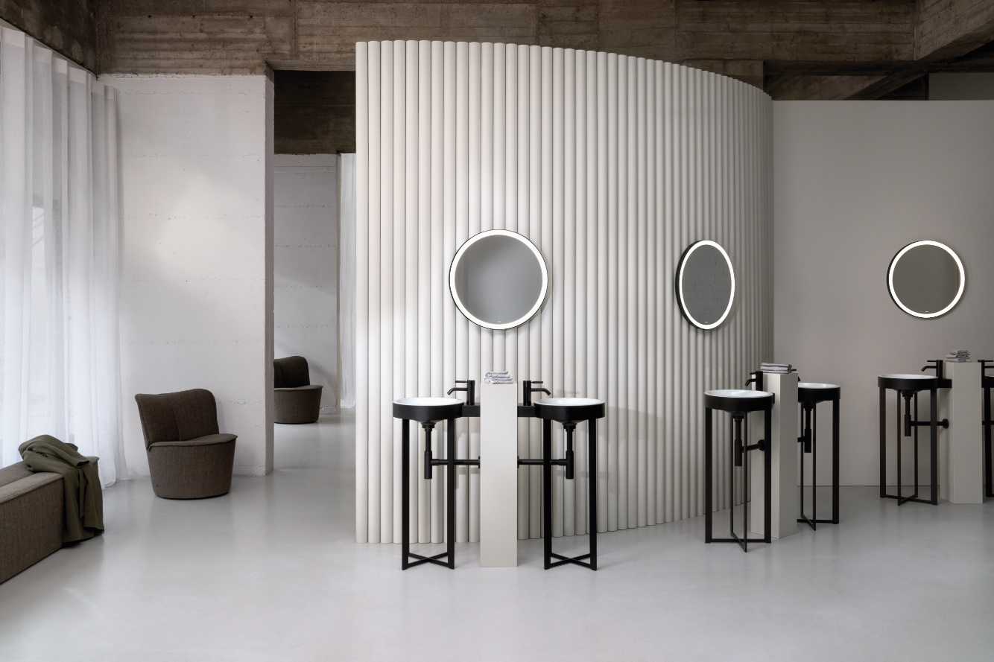
Alape_Xcross_010

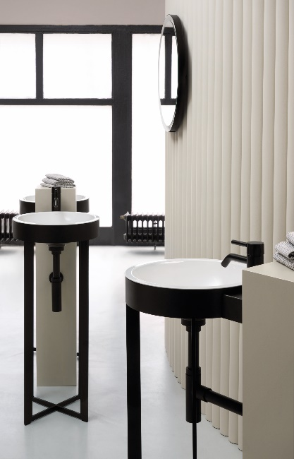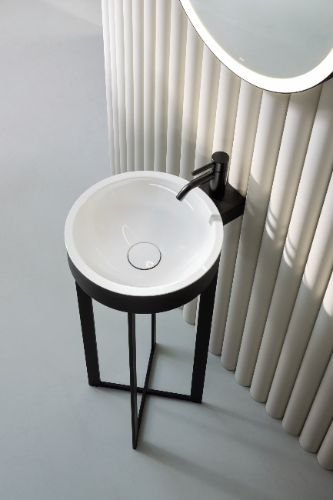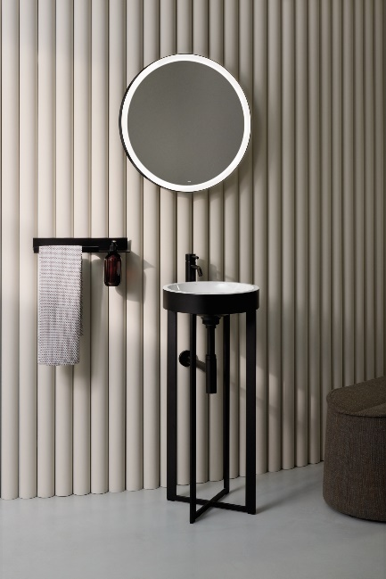
Alape_Xcross_02124 Alape_Xcross_021 Alape_Xcross_03176

Images: Xcut
Lightweight, precise, and entirely white: the new Xcut floor-standing washstand from Alape is beautifully engineered. The shelf, which is positioned under the basin, provides practical storage in the smallest of spaces.

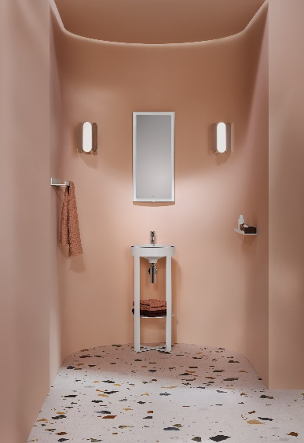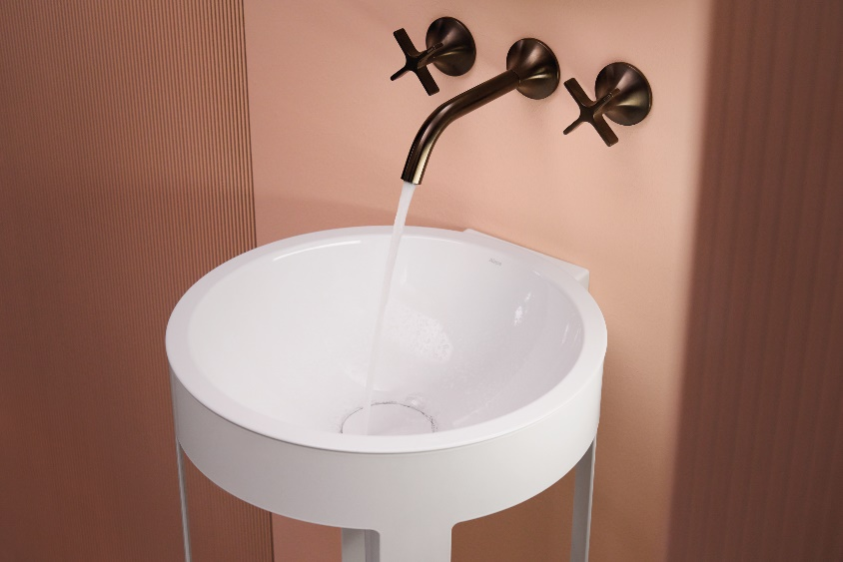
Alape_Xcut_04258 Alape_Xcut_06

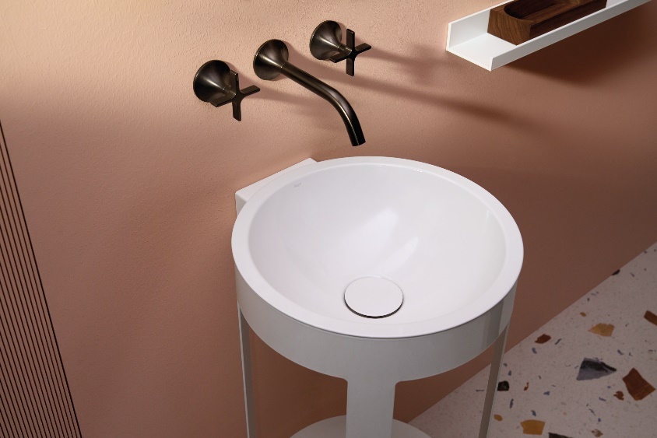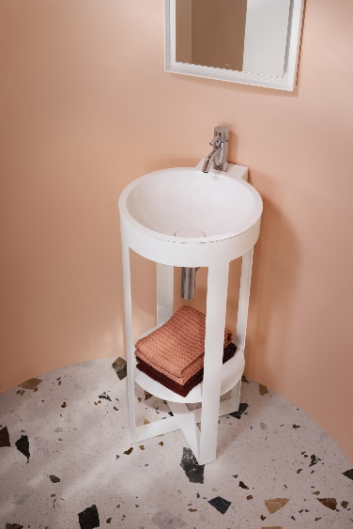
Alape_Xcut_022 Alape_Xcut_05330

Copyright © Alape GmbH

About Alape
Alape was founded in 1896 by Adolf Lamprecht in Penig as a company for enamel products. Today, the company produces aesthetic washplace solutions with around 100 employees at two production sites in Goslar. As a manufacturer, Alape stands for technical and functional quality standards and inspiring design. Glazed steel in combination with other high-quality materials enables Alape's individual design for an interior-influenced environment. Alape has been part of the Spanish Roca Group since October 2023.
alape.com

Press contact:
GeSK
Gabriele von Molitor
alape@gesk.berlin
Tel: +49 30 217 50 460

Alape
Marketing
marketing@alape.com
Tel. +49 5321 558-139

