Individualisation with a system:
Work.Frame^{x} for high-quality washstand solutions in the project area

Reduced design with an industrial character characterises the Work.Frame series from Alape. Based on the Work.Frame²⁰ and Work.Frame¹⁰⁰ ranges developed with Sieger Design, the manufacturer now presents Work.Frame^{X}: it is specially designed for the upmarket project sector and offers almost unlimited possibilities for designing washbasin areas in hotels and apartments to suit individual customer requirements. Each solution is unique, manufactured from high-quality materials and with high precision.

Prefabricated solutions with lots of service and freedom in planning – this is how customer-orientated project business works. The basis for Work.Frame^{X} is the filigree frame available in widths from 600 to 1200 mm. It is assembled floor-standing and aligned using height adjusters on the front legs. The rear struts deliberately end above the floor. This leaves space for an existing tile plinth and makes cleaning easier. Shelves made of grey safety glass are integrated into the frame; double washbasins can be created by connecting frames, the width of which is only limited by the available length of the respective support plate.

For Work.Frame^{X}, Alape offers a wide range of delicate and environmentally friendly Neolith support panels. The hygienic and sustainable natural stone is robust and impresses with its visual diversity. Neolith is made from natural raw materials, is produced in a carbon-neutral way and is 100 percent recyclable. In addition, individual materials can be used for the support panels at the customer's request for harmonious integration into the existing interior.

Work.Frame^{X} is crowned by a wide range of countertop basins made of glazed steel just a few millimetres thick. Alape offers a comprehensive selection of sizes, shapes, surfaces and colours. In keeping with the holistic approach, the washplace can be stylishly completed with designer mirrors and the Alape Assist storage system.

Based on the basic principle of the Work.Frame^{X} solutions, further individual adaptations can also be made. From the surface of the powder-coated frame to design modifications, the system can be adapted in a variety of ways to meet customer requirements. Wall-mounted solutions or integrated furniture elements are conceivable. Dimensional adaptations are also possible at any time, depending on the construction task.

Individualisation with a system:
Work.Frame^{X} for high-quality washstand solutions in the project area

Work.Frame^{X} is based on a filigree frame that can be installed floor-standing and adjusted using height adjusters on the front legs. Shown here is the 1200 mm-wide version with the Neolith support panel in Calatorao Silk, the UNISONO basin in white and the designer mirror SP.FR1000.R1 from Alape with a diameter of 1000 mm.
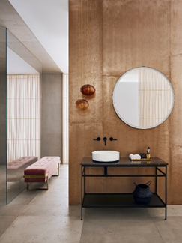

Work.Frame^{X} is complemented by a wide range of countertop basins made of thin-walled steel in a wide variety of sizes, shapes, surface finishes and colours. An example: the Scopio SB.CO375 bowl basin in matt black
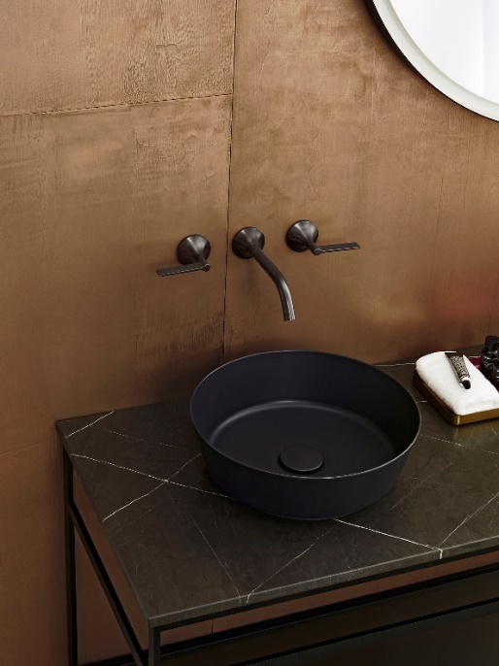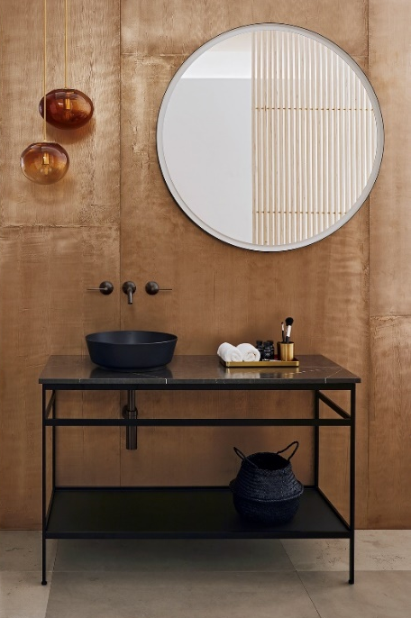
Copyright © Alape GmbH

In the self-check-in hotel The Adams in Baden-Baden, Work.Frame^{X} proves to be a flexible space miracle and eye-catcher: the seven rooms were created from former hotel staff accommodation and are comparatively small. Some bathrooms measure less than three square metres. In some cases, the washing area is located directly in the bedroom. The limited space is offset by the high-quality furnishings. In order to combine homely comfort and design, Work.Frame^{X} from Alape was chosen for the washbasins. The dimensions of the elements were optimally adapted to the available space. The open washstand solution fits perfectly into the deliberately transparent room concept. The result is an intelligent washplace solution with a modern design and storage space that has been very well received by guests.

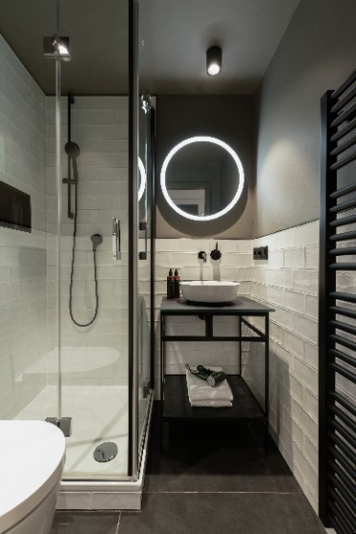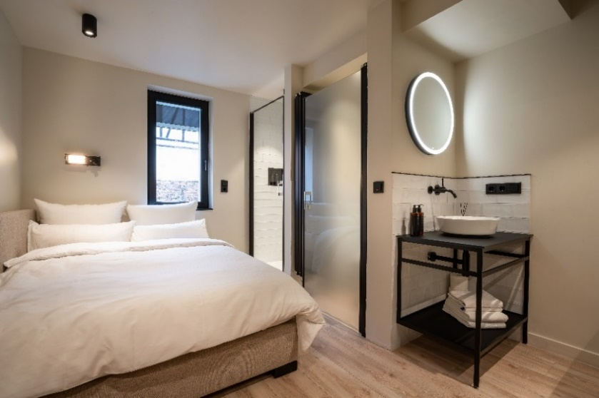
Copyright © The Adams

About Alape
Alape was founded in 1896 by Adolf Lamprecht in Penig as a company for enamel products. Today, the company produces aesthetic washplace solutions with around 100 employees at two production sites in Goslar. As a manufacturer, Alape stands for technical and functional quality standards and inspiring design. Glazed steel in combination with other high-quality materials enables Alape's individual design for an interior-influenced environment. Alape has been part of the Spanish Roca Group since October 2023.
alape.com

Press contact:
GeSK
Gabriele von Molitor
alape@gesk.berlin
Tel: +49 30 217 50 460

Alape
Marketing
marketing@alape.com
Tel. +49 5321 558-139

