Nature as inspiration. Terra and Aqua from Alape
With the versatile and innovative Terra and Aqua surfaces, Alape takes nature as its model: Terra is characterised by a matt, novel powdery finish and subtle pastel colour nuances. Aqua impresses with a glass-like surface and deep, rich blue and green tones.

Surfaces represent the interface between the human body and the material world that surrounds it. They therefore have a direct influence on our well-being. When developing the Terra and Aqua surfaces, Alape therefore focused on the increased need for naturalness in all our living spaces. Natural colours and shapes also ensure familiarity and comfort in the bathroom – making it a feel-good place for body and soul. The inspiration for the two surfaces came directly from nature: the watery worlds of the ocean as well as the natural texture and colour of stone.

With Terra, Alape has developed a surface that is reminiscent of minerals: the matt, powder-like finish evokes associations with the finest mineral particles. Even before you touch it, you can sense the velvety and warm feel. The grey nuanced spectrum of the four colour versions Nordic Matt, Oyster Matt, Silk Matt and Gravel Matt supports this sensual and pleasantly soft impression. Thanks to their naturalness, the different colour variants allow both harmony and mutual dominance with the surrounding materials.

Aqua, on the other hand, impresses with an optical depth that is otherwise only known from glass. The gently shimmering surface structure is unique: its colour gradient varies slightly each time, making the individual basins unique. How the colour is perceived also depends on the materials used in the surroundings and the respective lighting situation. Aqua is available in the three colour nuances Deep Blue, Deep Green and Deep Indigo, which are closely based on the colour worlds of the oceans.

Manufacturing the two surface variants proves to be extremely challenging. Enamelling Terra and Aqua requires calm and care: glazing with matt colours, as with Terra, is particularly time-consuming, and even the composition and production of the enamel slip is a challenge. With Aqua, the characteristic depth effect is created during the manufacturing process by adding a certain amount of clear enamel to the glaze. The glaze is consistently a maximum of 0.3 mm thick.

With Aqua and Terra, Alape is not only underlining its own competence and many years of expertise in enamel, but also enhancing its existing product range. The DNA of the traditional company is thus emphasised even more strongly: clear, precise, innovative.

Nature as inspiration. Terra and Aqua from Alape
Aqua impresses with an optical depth that is otherwise only known from glass. The softly shimmering surface texture is unique.

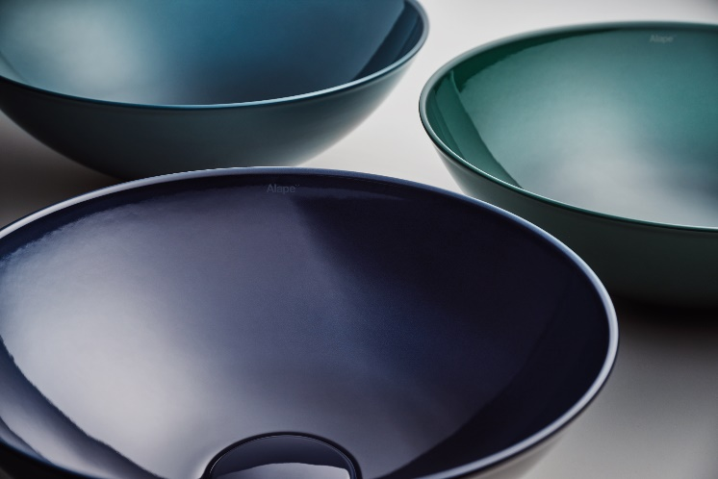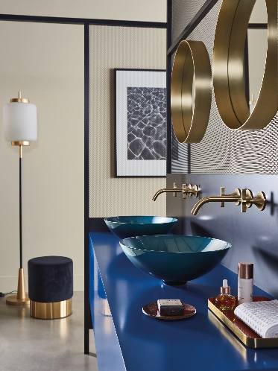
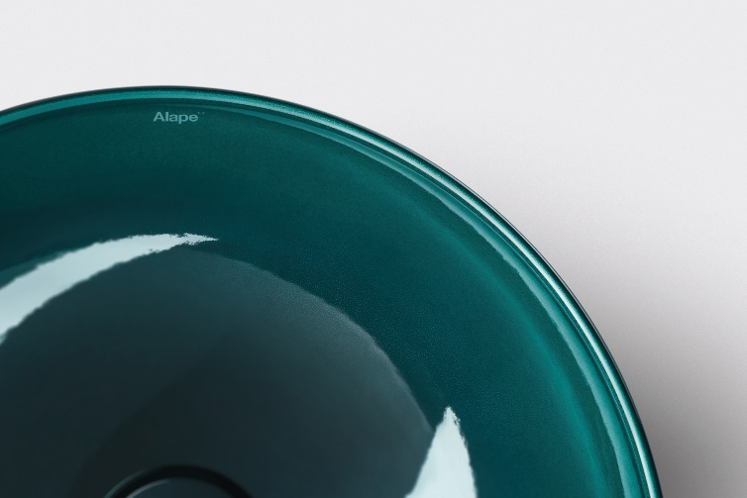
Alape_Aqua

With Terra, Alape has developed a surface that is reminiscent of minerals: the matt, powder-like finish evokes associations with the finest mineral particles. Even before you touch it, you can sense the velvety and warm feel.

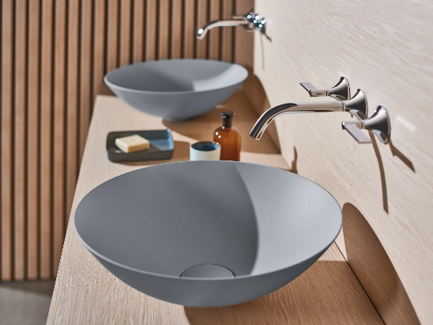 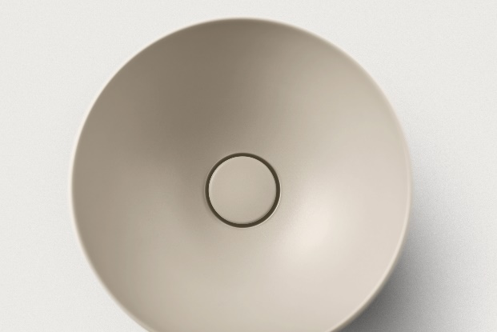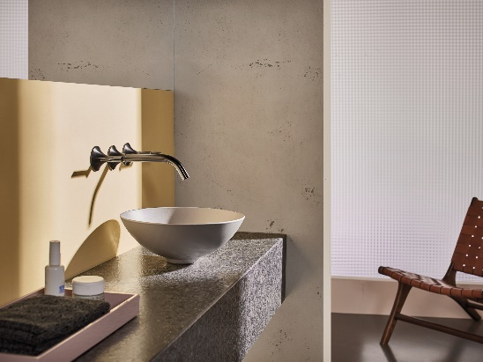 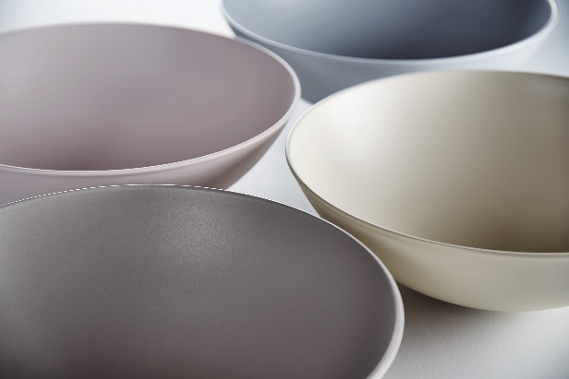
Alape_Terra
Copyright © Alape GmbH

About Alape
Alape was founded in 1896 by Adolf Lamprecht in Penig as a company for enamel products. Today, the company produces aesthetic washplace solutions with around 100 employees at two production sites in Goslar. As a manufacturer, Alape stands for technical and functional quality standards and inspiring design. Glazed steel in combination with other high-quality materials enables Alape's individual design for an interior-influenced environment. Alape has been part of the Spanish Roca Group since October 2023.

alape.com

Press contact:
GeSK
Gabriele von Molitor
alape@gesk.berlin
Tel: +49 30 217 50 460

Alape
Marketing
marketing@alape.com
Tel. +49 5321 558-139

