Embracing Water for 125 Years.
A company portrait of Alape

The history of Alape begins in 1896 in Penig, Saxony, where Adolf Lamprecht founds a company for enamel products and gives it a sonorous name: "A" refers to Adolf, "LA" to Lamprecht and "PE" to Penig. The company is characterised by the dynamic spirit of optimism associated with industrialisation – but also feels connected to movements such as the Arts and Crafts movement, which evokes craftsmanship and simplicity in form and material.

Glazed steel became the preferred material early on: in 1930, Alape used it to produce the first sink, millions of which were sold over the decades. In the 1970s, the company finally drew attention to itself for the first time with progressive designs, gaining the lasting appreciation of architects and interior designers worldwide. Today, the company produces basins, washstands and many other bathroom products at its Goslar site. As a premium brand, it stands for innovative technology, high quality standards at manufactory level and a concise, precise design language.

Glazed steel: unique precision in manufactory quality
The preferred material is still glazed steel. It is the starting point for every product development, a benchmark of perfection, a pioneering compass and an inspiring source of inspiration. The material enables design diversity and precision, while the glass shell gives the designs their durability and reliably holds even the most delicate geometries in shape. Titanium-stabilised and low-carbon, it is extremely hard-wearing, has excellent hygiene properties and enables extremely precise, delicate processing. In addition to glazed steel, it is the manufacturing quality in particular that gives Alape products their specific character: every basin, every washstand is a one-off, the result of the interplay between specialised manual production and automated sub-processes.

Timeless shapes, creative partnerships and the elemental connection to water
Alape also meets the highest standards in terms of aesthetic design: the focus is on holistic thinking and a reduced, timeless aesthetic that is characterised by exact geometries and minimal radii. The company has been in close contact with designers, artists and architects for decades. The fact that the demands placed on human living spaces are constantly changing serves as a continual starting point for innovative concepts and design ideas. Alape has been working with renowned partners such as Sieger Design and Busalt Design for a long time: together, they continue to develop the product design in the spirit of the brand, constantly exploring new solutions and manufacturing processes.
Last but not least, the element of water itself remains an essential and enduring inspiration for the creative and technical process. Alape products embrace water and shape it; only in interaction with it do they themselves come to life, find their purpose and destiny. This special connection is also reflected in the company's logo: the small semicircle stands for the shape of a basin and at the same time symbolises the gesture of "holding water".

A multifaceted portfolio full of innovation
Alape's current product portfolio is as varied as these influences are diverse. In 2019, for example, the award-winning industrial washplace "Steel19" was created, which refers to the legendary sink from 1930 with a modern look and a contrasting material composition. The modular furniture programme "Arkta" also caused a sensation with its flexibly configurable design components. The brand recently underlined its expertise in the area of surface design with the "Aqua" and "Terra" series, whose designs are influenced by the water worlds of the ocean and the natural texture of stone. With "bespoke", a range was also presented at the beginning of 2024 that opens up an almost unlimited number of options for customising washplaces: architects and planners can use it to adapt products to all project requirements far beyond series standards.

Changing bathroom design: sustainability and individuality at Alape
The company's product range reflects developments that have played a significant role in bathroom design in recent years: for example, the bathroom has become increasingly important. Due to the desire for expressive and, above all, personal interiors, it will play a special role in future as an individually designed, comfortable retreat. The focus is therefore on authentic, sustainable materials and striking designs that reflect one's own personality. Alape responds to this trend with a holistic approach: coordinated complete solutions comprising bathroom furniture, washbasins, bathroom mirrors and accessories that skilfully combine an expressive design language with functionality.
As an additional, important point for the needs of the present and future, sustainability is an essential part of the company philosophy. Every product comes with a 25-year guarantee. Short procurement channels, local supply and recyclable packaging materials are further components of a respectful approach to nature.

Alape and Roca: "A promising partnership for the future of bathroom design"
Since October 2023, Alape has been part of the Spanish Roca Group, one of the global market leaders and trendsetters in the bathroom furnishings sector. The integration gives the premium manufacturer from Goslar new perspectives, enabling it to sustainably expand its own sales structures and open up new markets for its products. Being part of Roca also gives Alape the opportunity to work with renowned brands that are part of the corporate family – to jointly expand design boundaries, set new standards and shape bathroom design of the future.

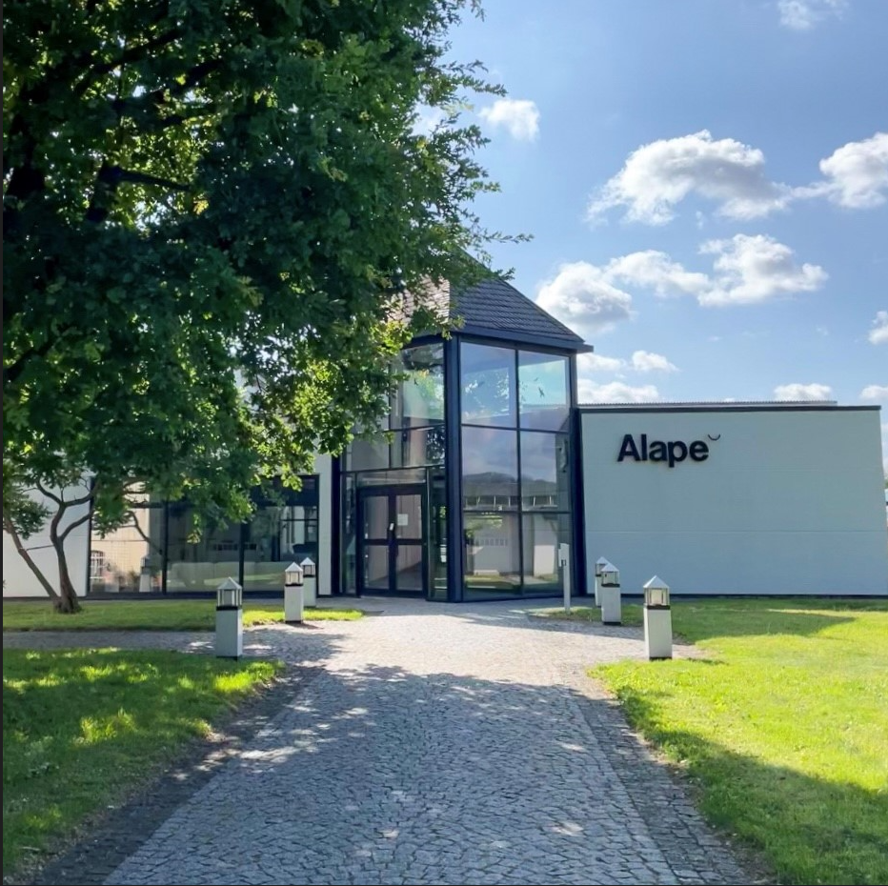
For 125 years, Alape has stood for innovation, quality and precision: at its current site in Goslar, the company manufactures designer basins, washstands and bathroom solutions made of glazed steel.

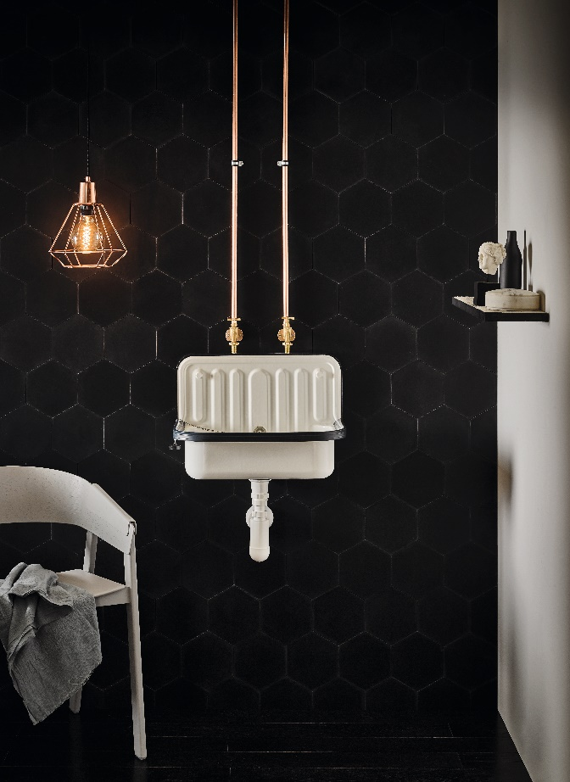 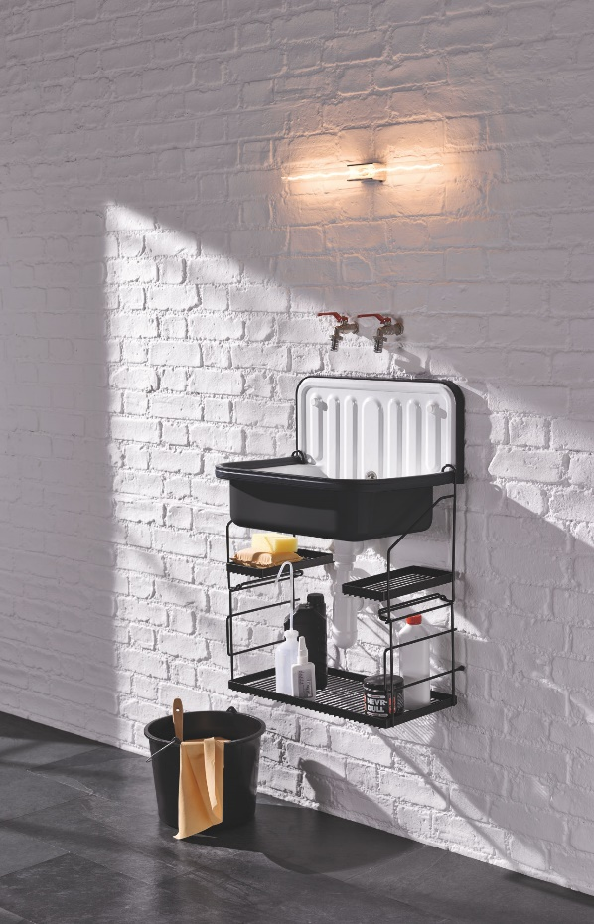
The popular sink from Alape from 1930 is a worldwide classic. Right: Bicolour finish.

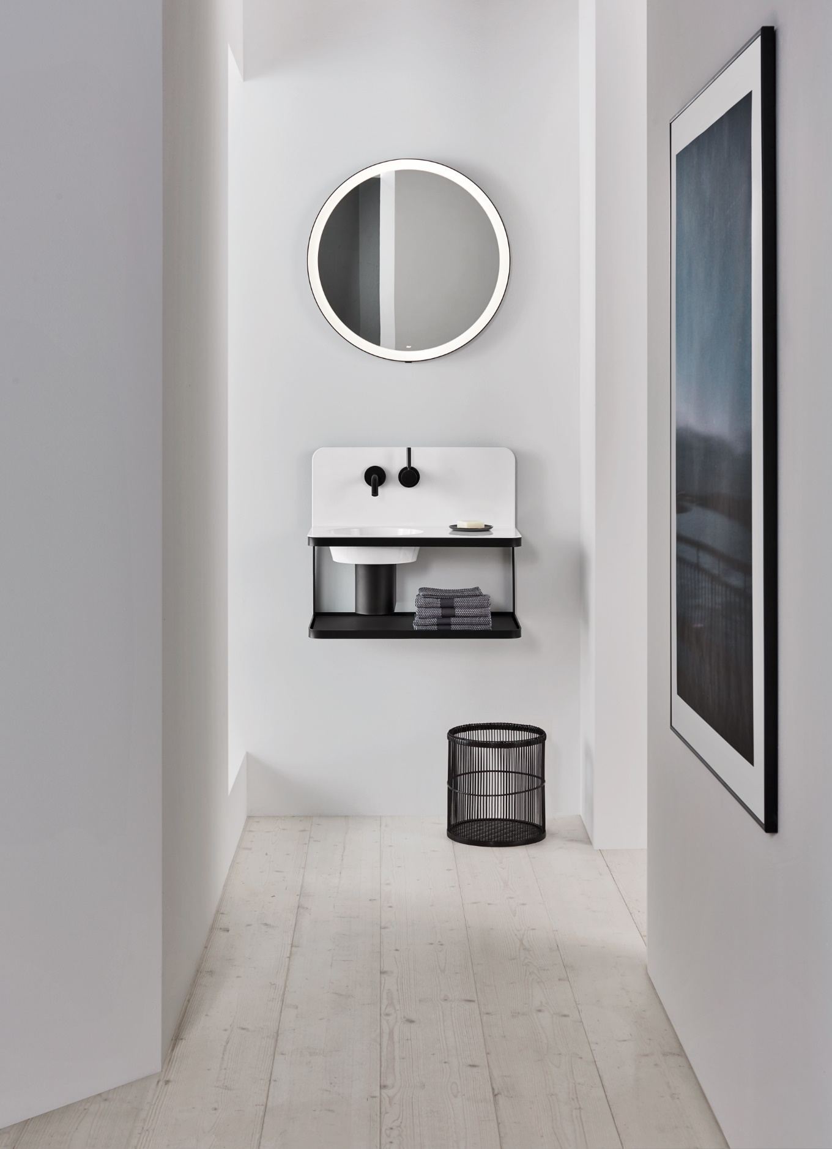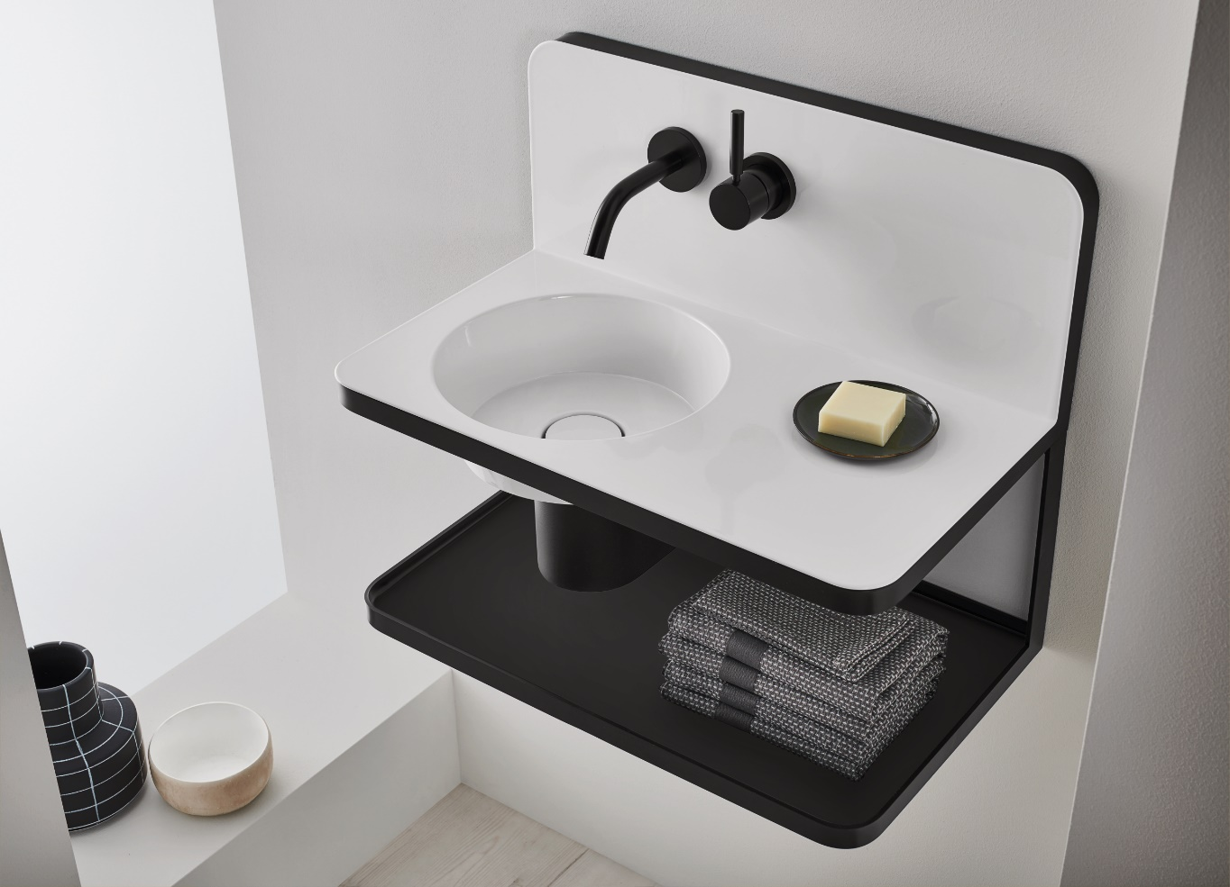
The award-winning industrial washplace "Steel19" is reminiscent of the legendary sink from 1930 with a modern look and a contrasting material composition.

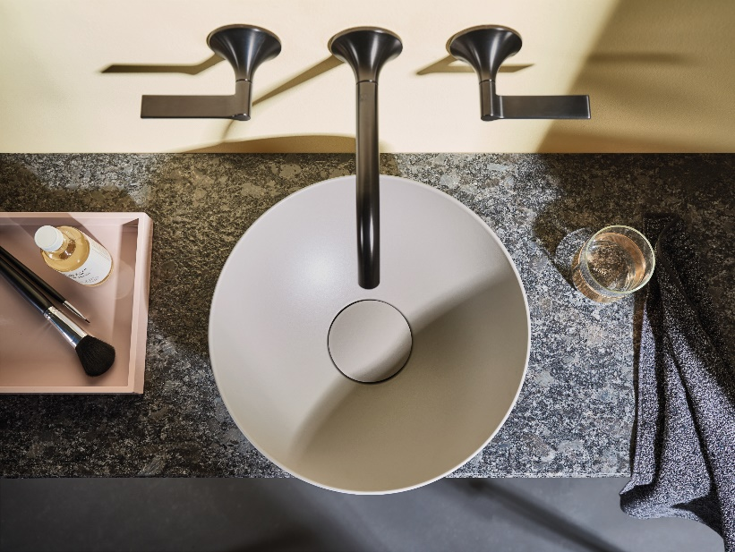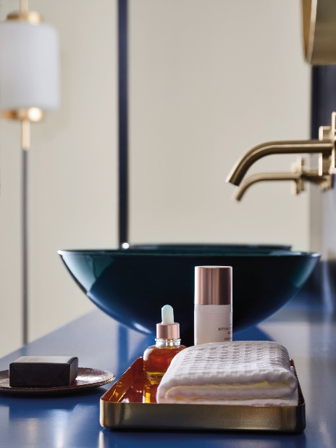
Inspired by the natural texture of rock and the watery worlds of the ocean: Alape demonstrates its expertise in the field of surface design with "Terra" and "Aqua".

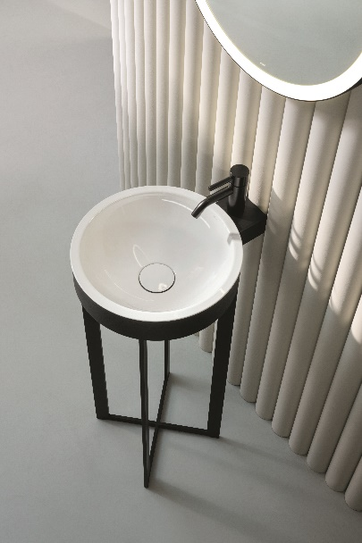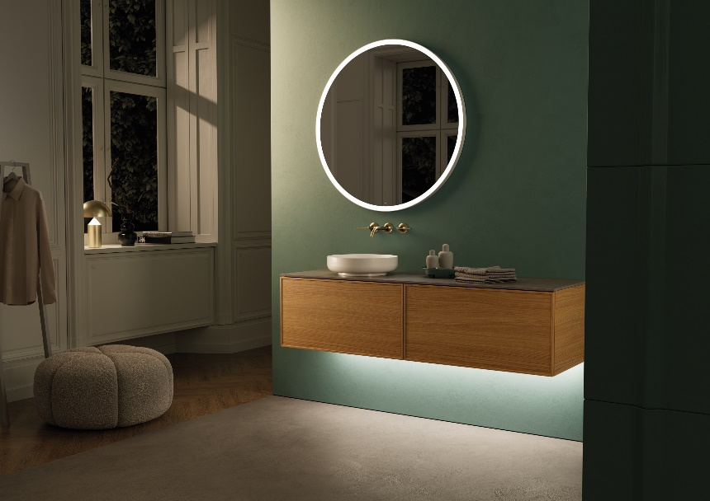
Left: The Xcross column washstand was recognised for its outstanding design quality at the ICONIC AWARDS in 2023.
Right: The modular furniture range "Arkta" with its flexibly configurable components skilfully combines expressive design with functionality.

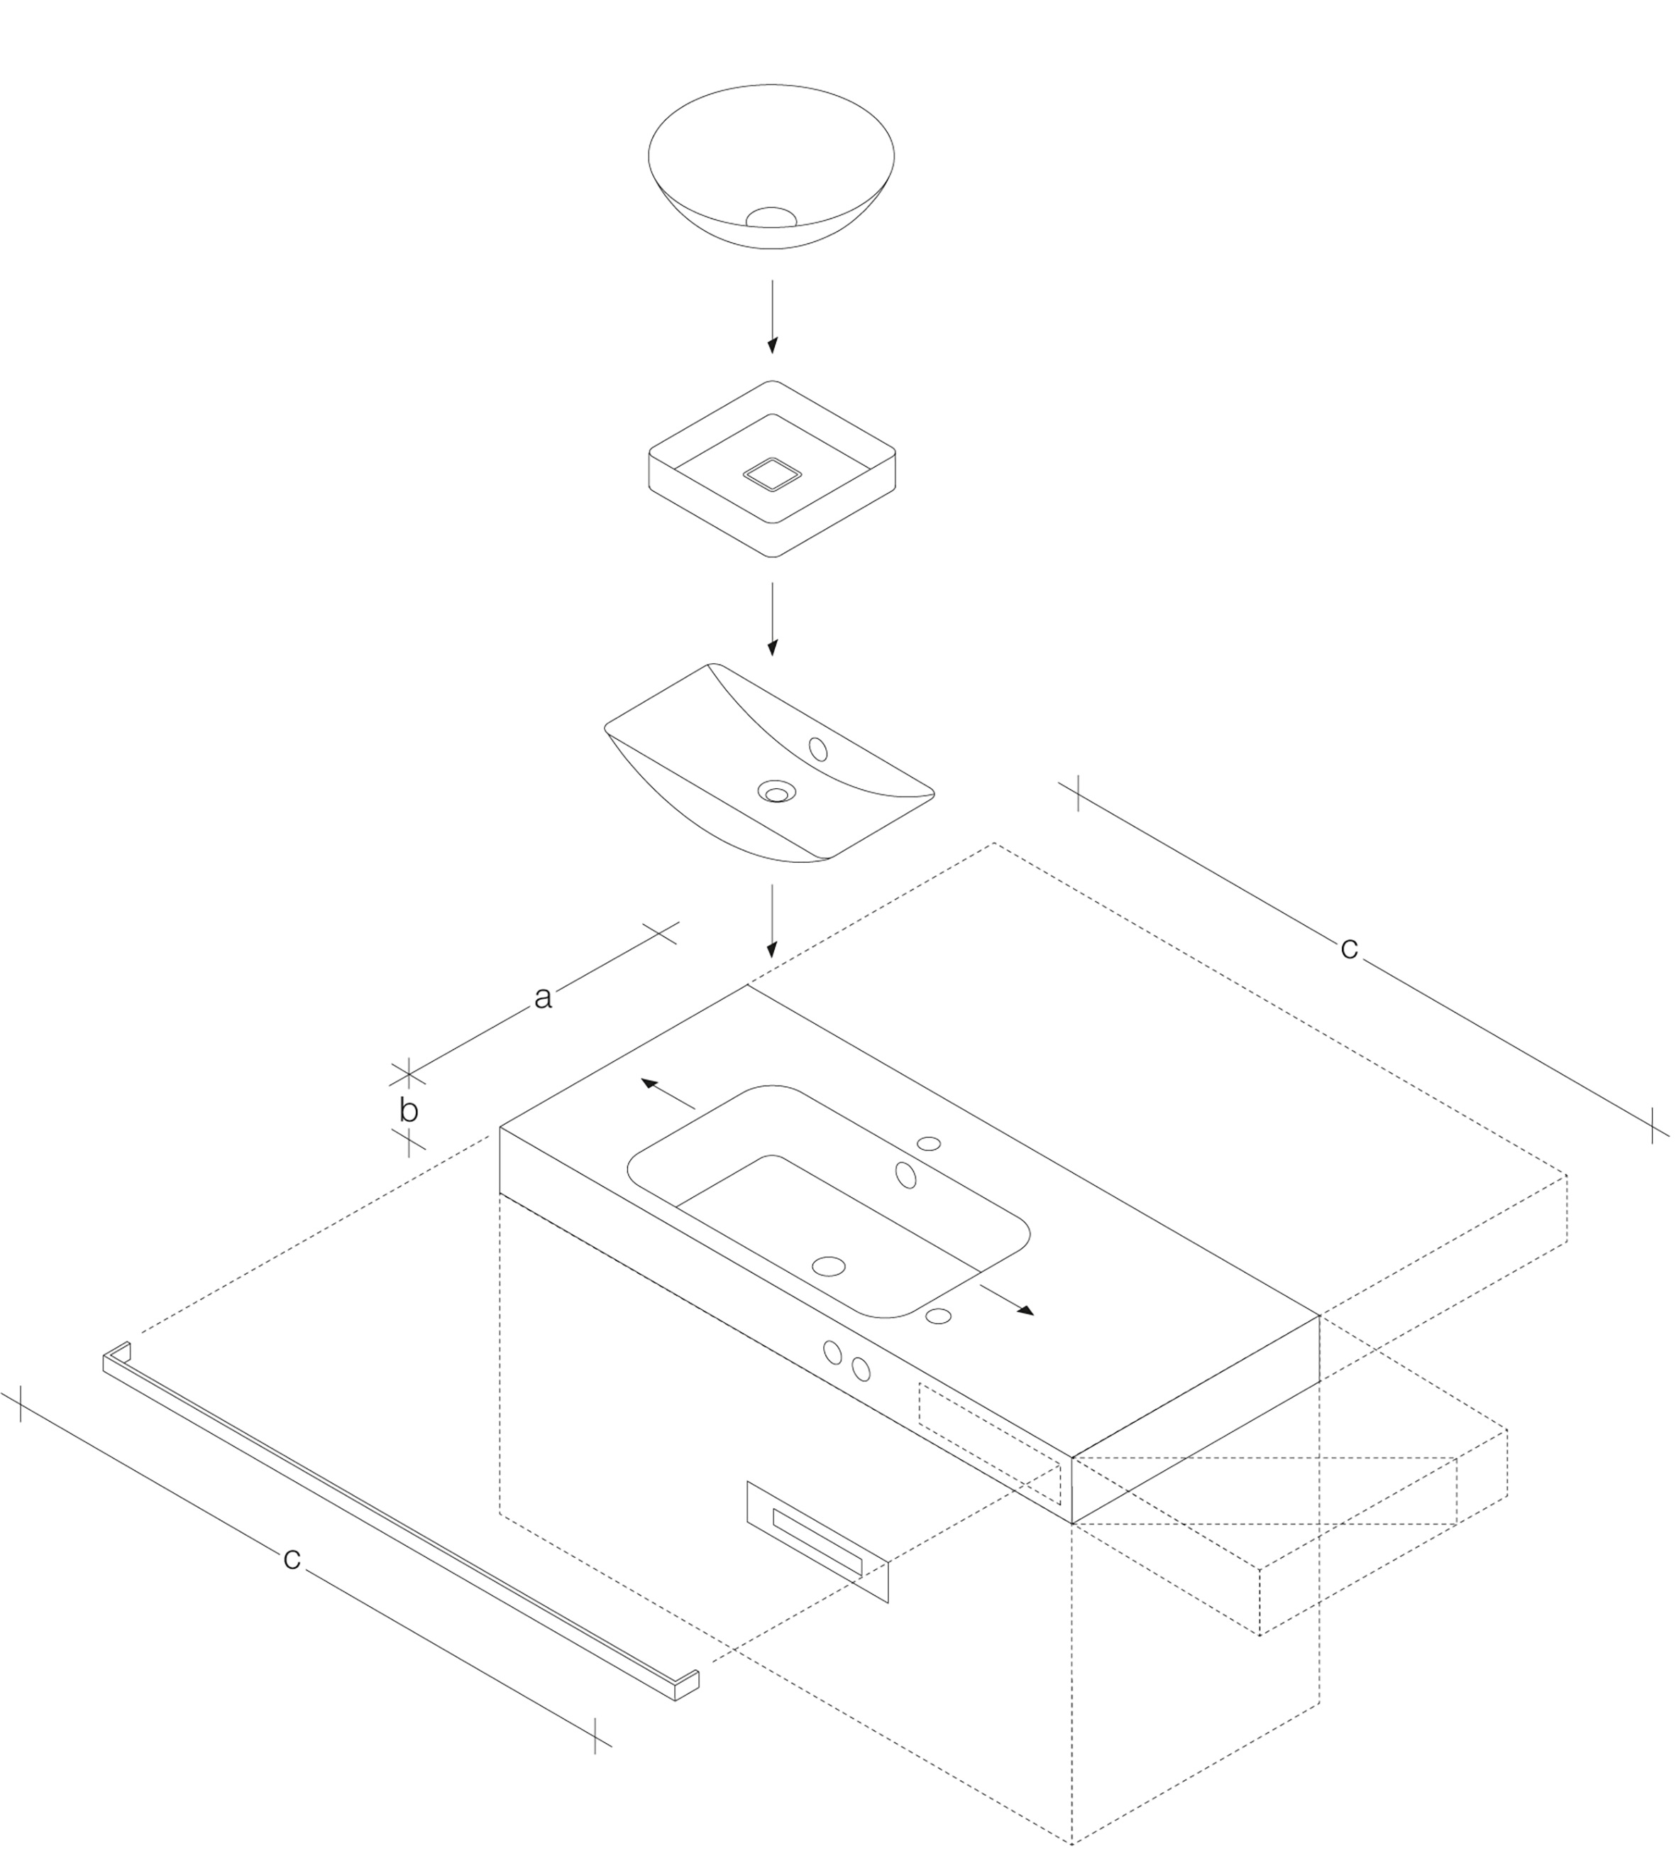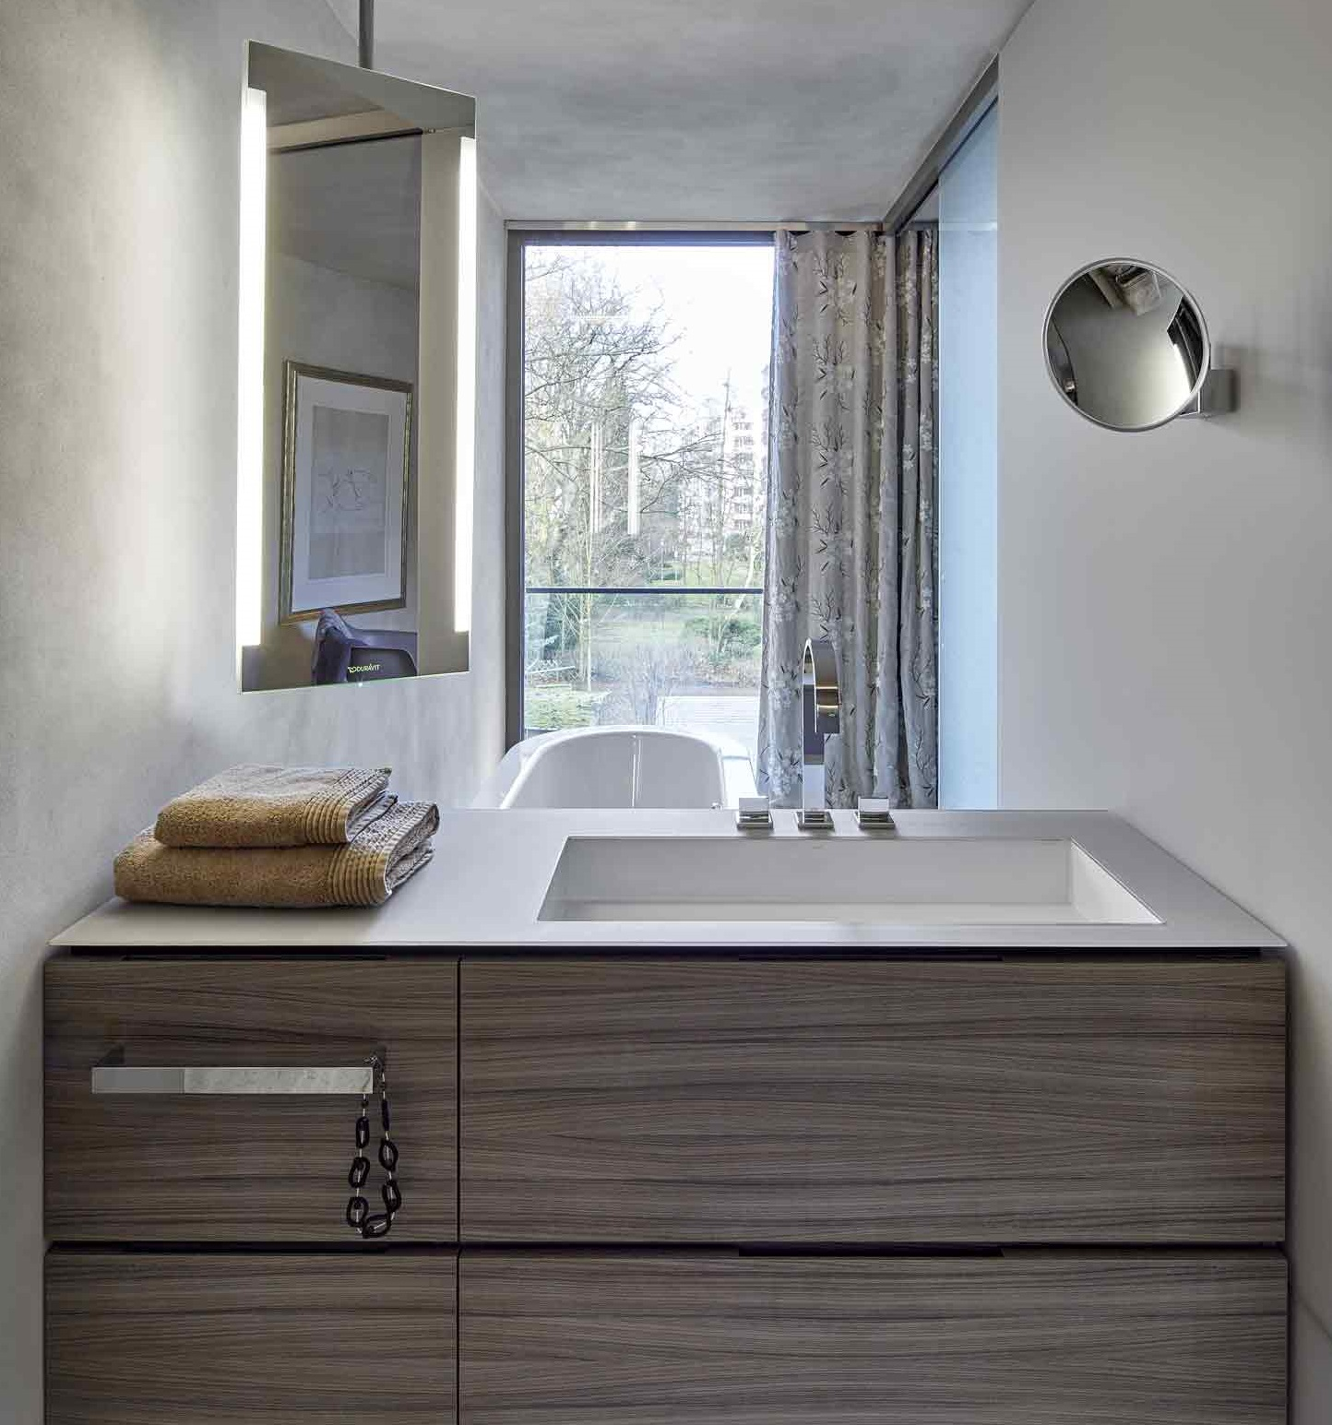

"bespoke" opens up an almost unlimited number of possibilities for customising washplaces.

About Alape
Alape was founded in 1896 by Adolf Lamprecht in Penig as a company for enamel products. Today, the company produces aesthetic washplace solutions with around 100 employees at two production sites in Goslar. As a manufacturer, Alape stands for technical and functional quality standards and inspiring design. Glazed steel in combination with other high-quality materials enables Alape's individual design for an interior-influenced environment. Alape has been part of the Spanish Roca Group since October 2023.
alape.com

Press contact:

GeSK
Gabriele von Molitor
alape@gesk.berlin
Tel: +49 30 217 50 460

Alape
Marketing
marketing@alape.com
Tel: +49 5321 558-139

